**Homework 2: Route Finding**

**Part I. Implementation (6%):**

**Part1:**

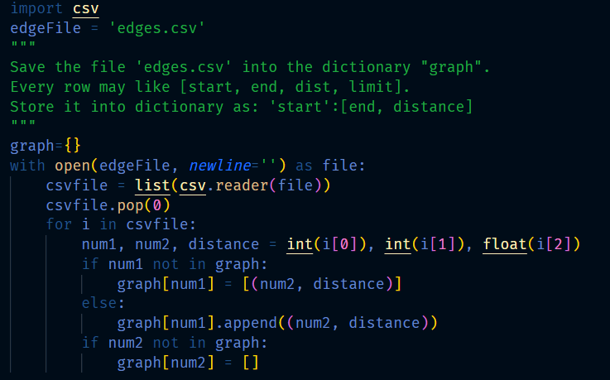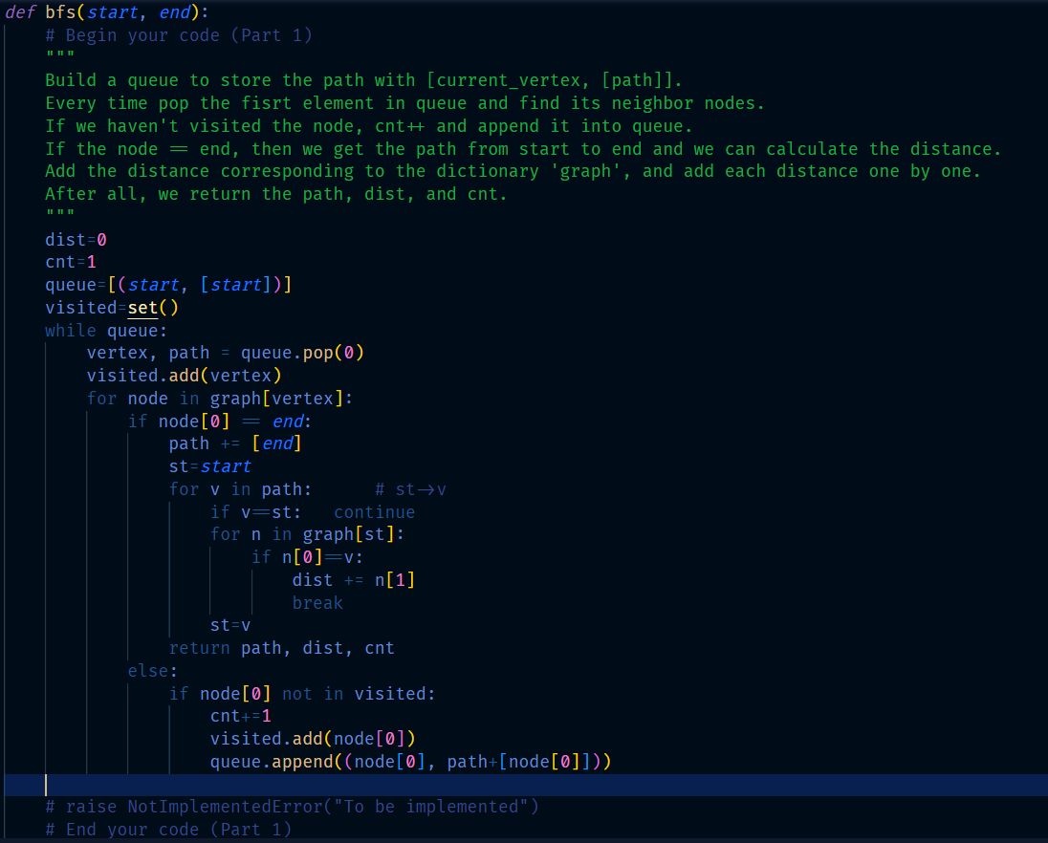

**Part2:**

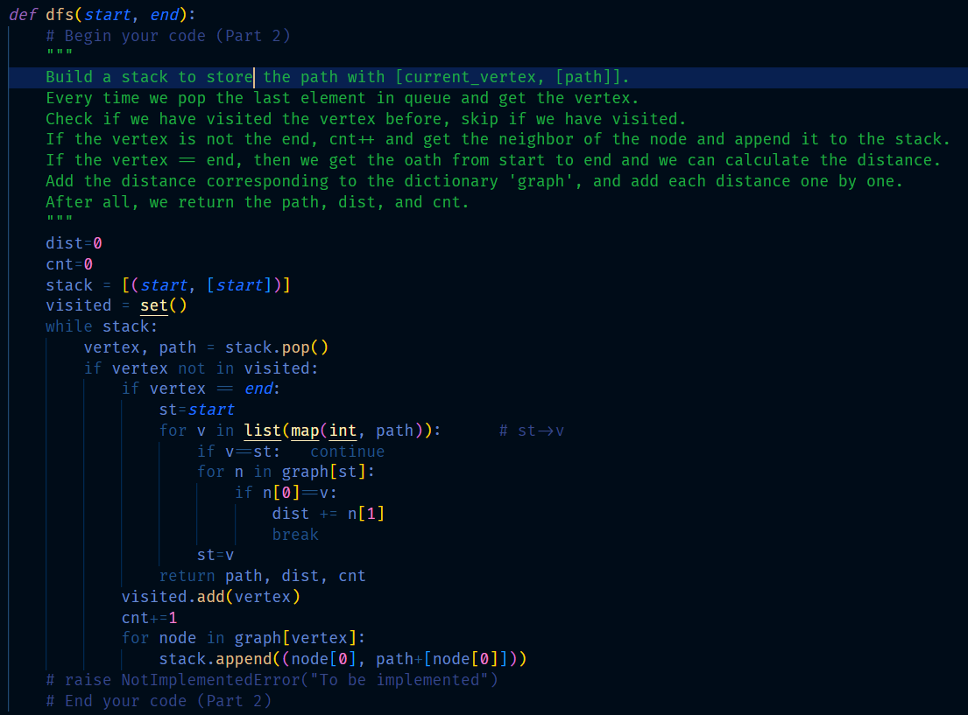

**Part3:**

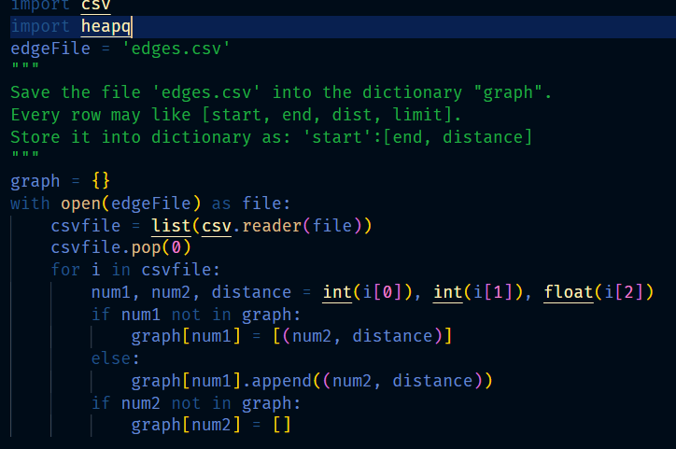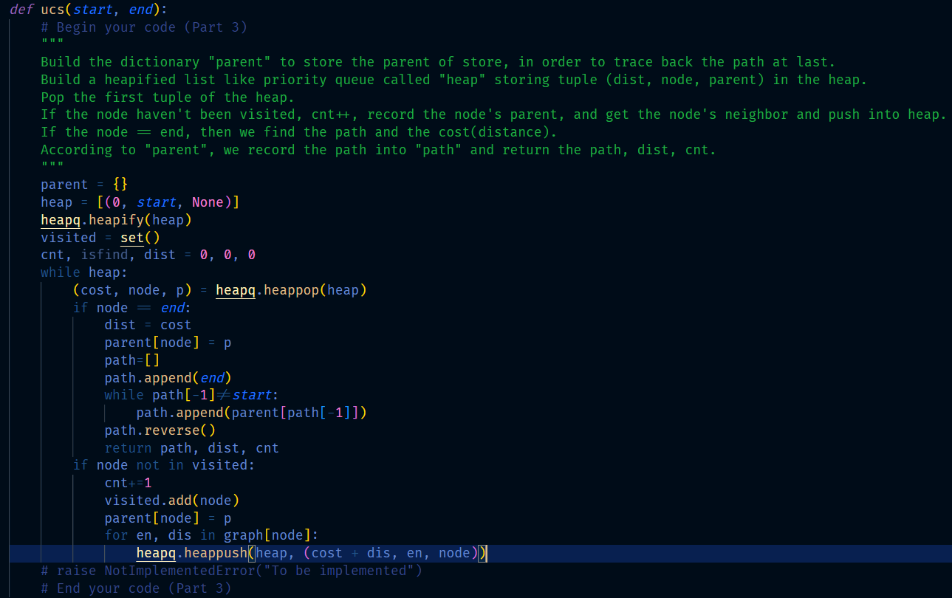

**Part4:**

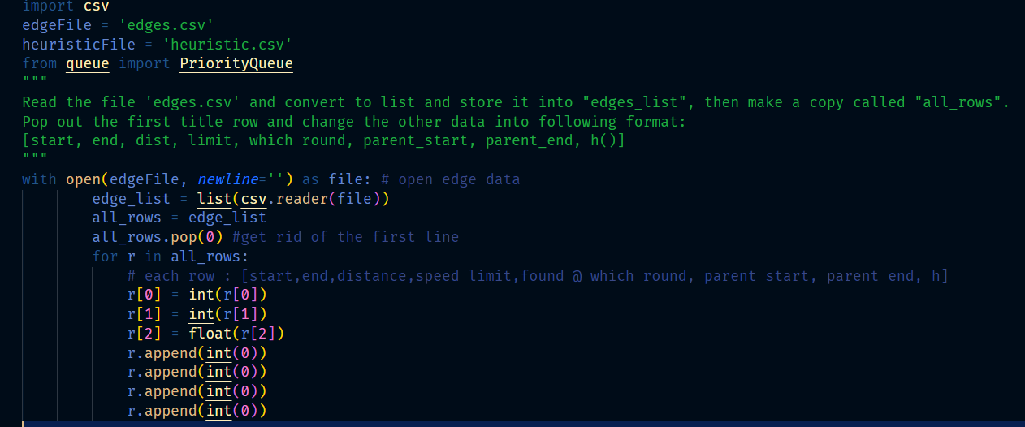

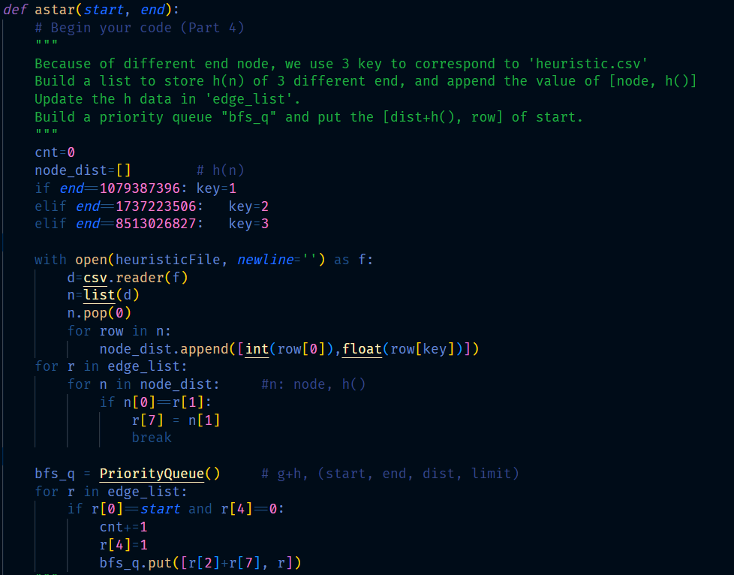

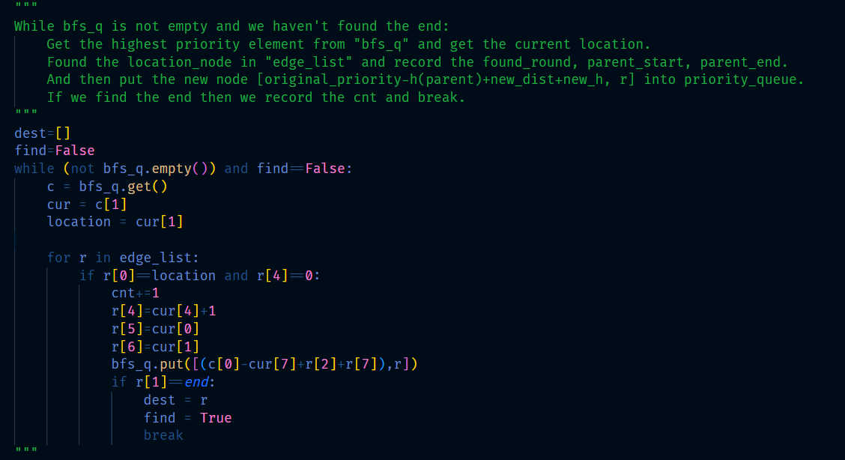 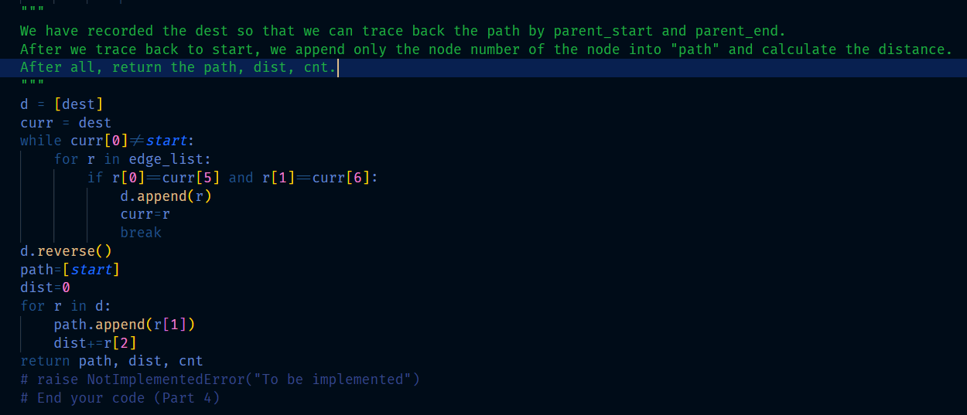

**Part II. Results & Analysis (12%):**

Test1: from National Yang Ming Chiao Tung University (ID: 2270143902)

to Big City Shopping Mall (ID: 1079387396)

BFS:

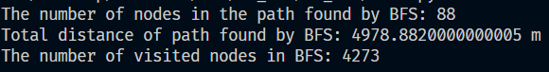

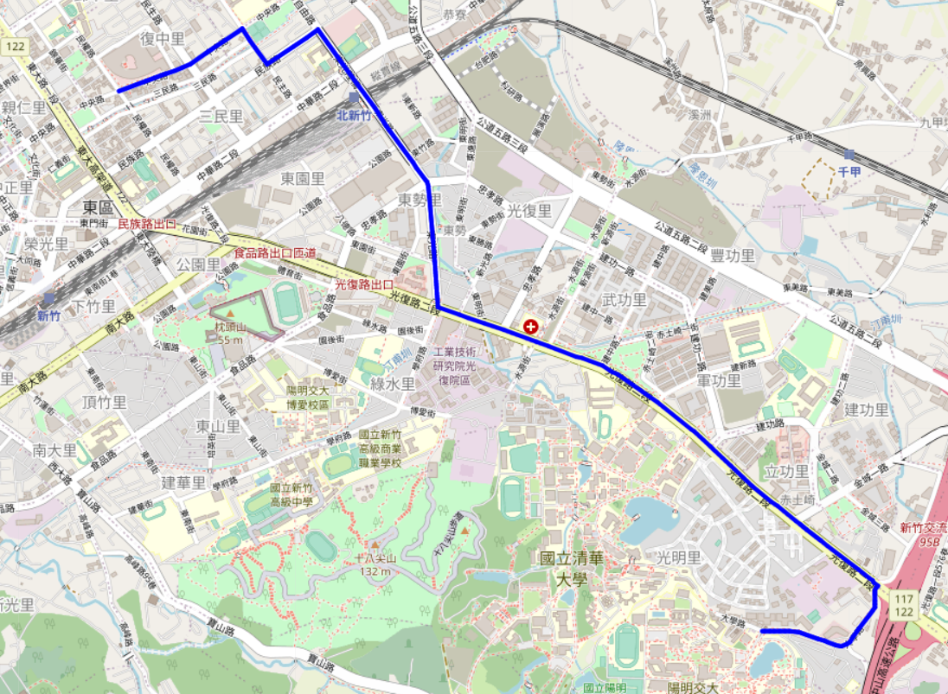

DFS (stack):

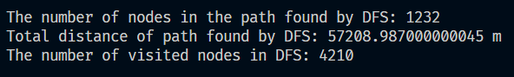

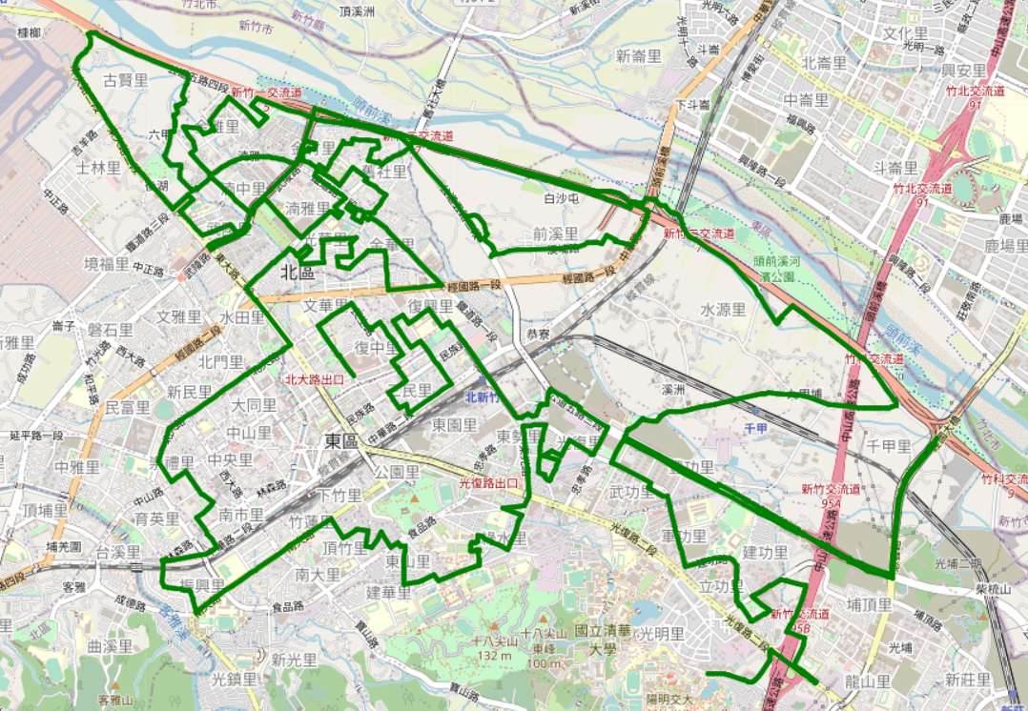

UCS:

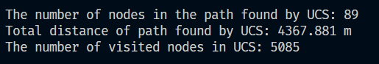 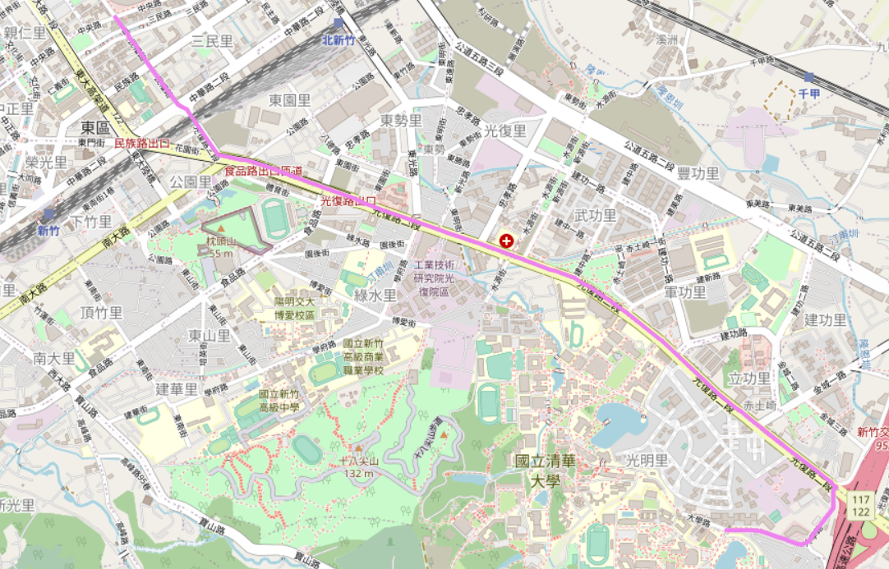

A*:

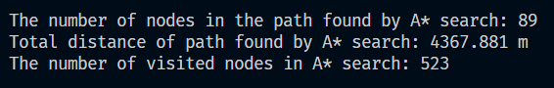

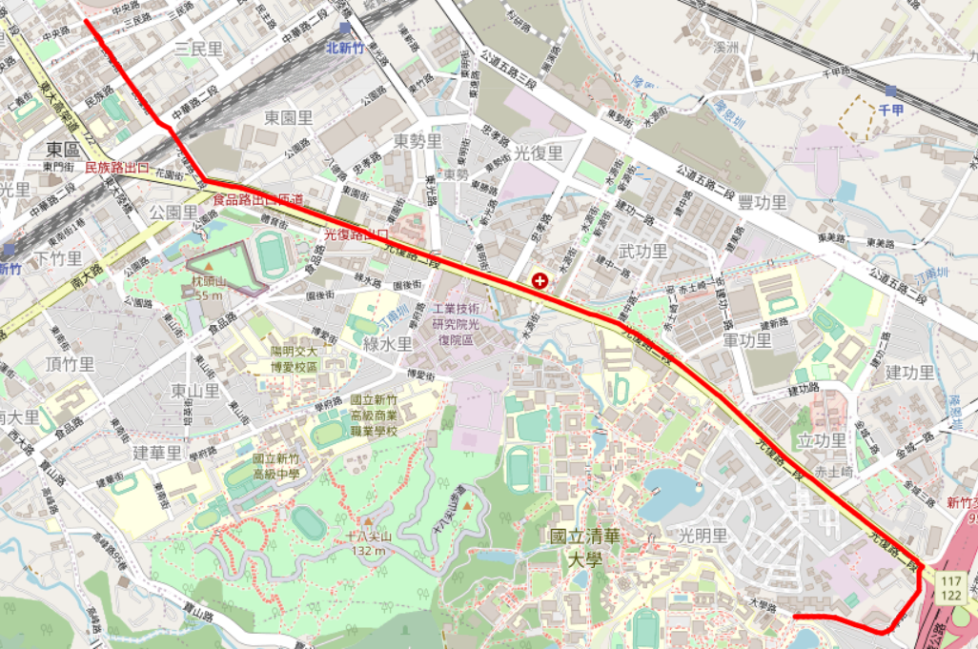

Test2: from Hsinchu Zoo (ID: 426882161)

to COSTCO Hsinchu Store (ID: 1737223506)

BFS:

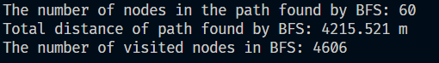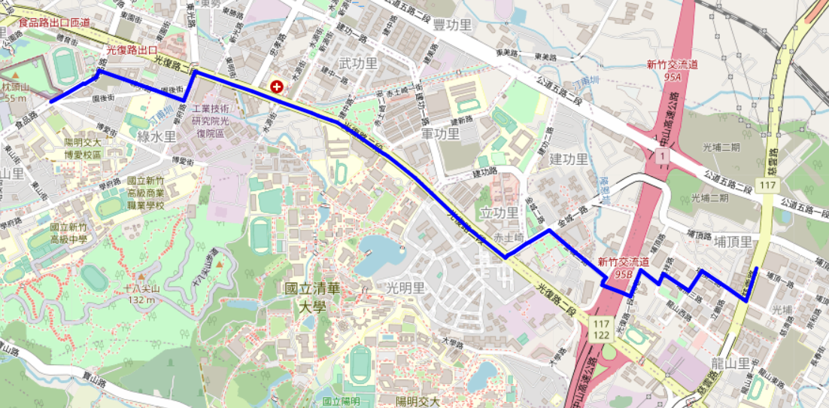

DFS (stack):

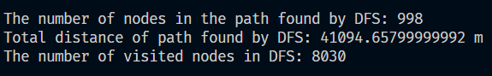 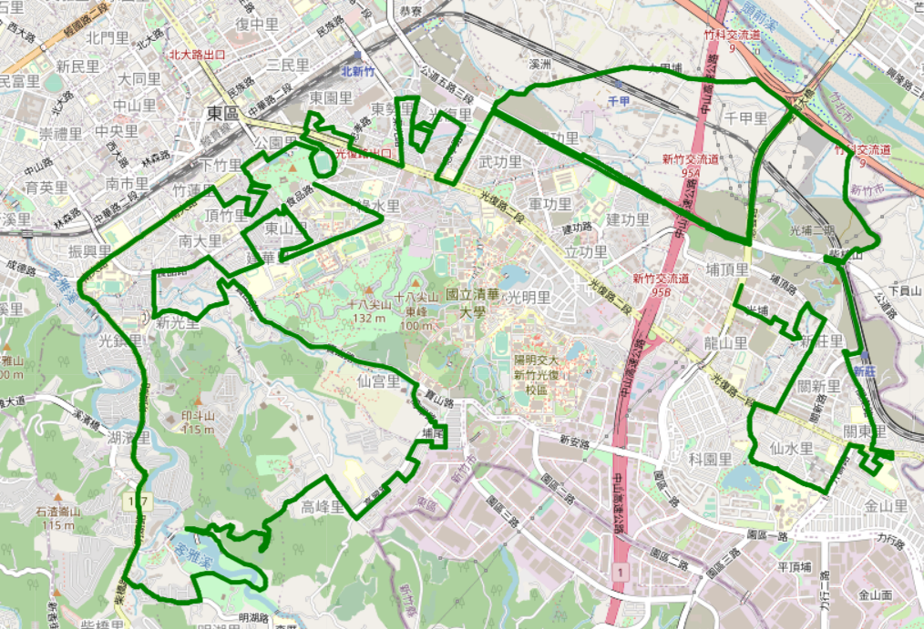

UCS:

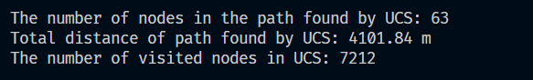 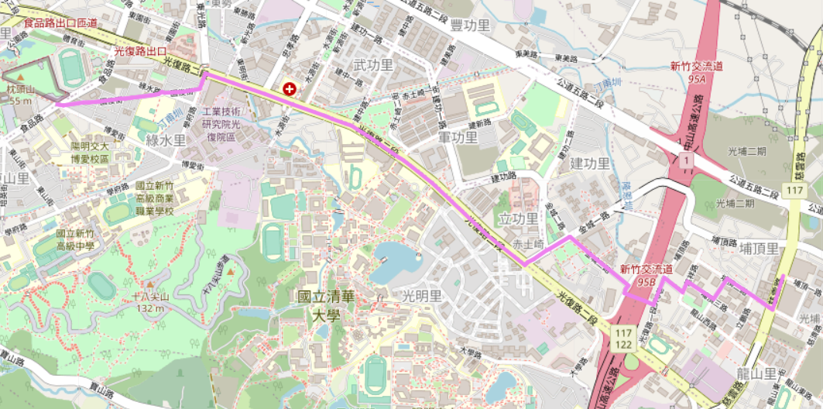

A*:

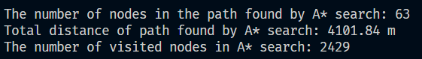 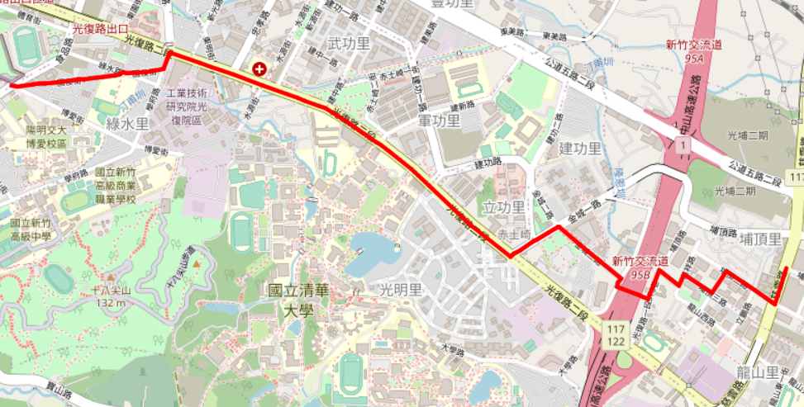

Test3:

from National Experimental High School At Hsinchu Science Park (ID: 1718165260)

to Nanliao Fighing Port (ID: 8513026827)

BFS:

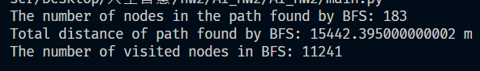 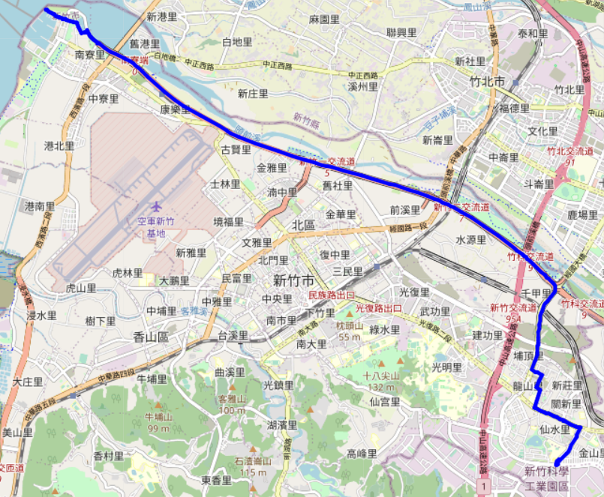

DFS (stack):

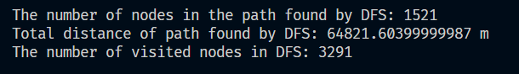

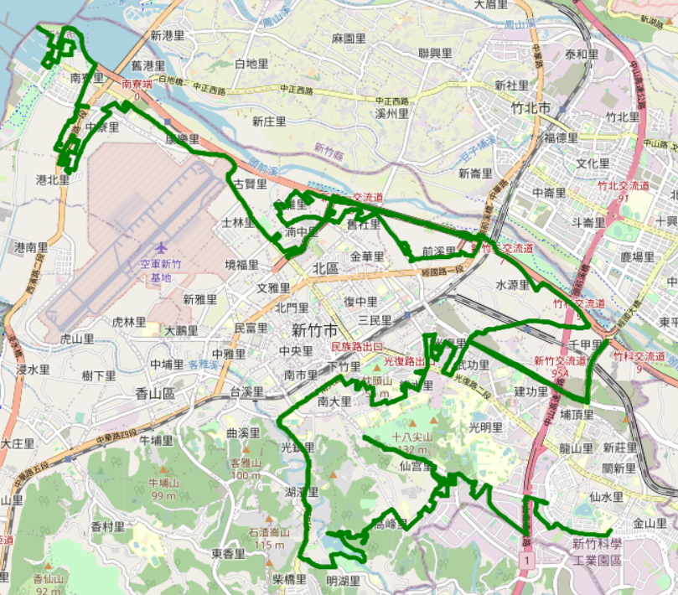

UCS:

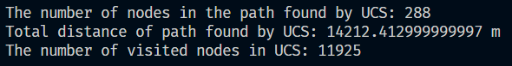 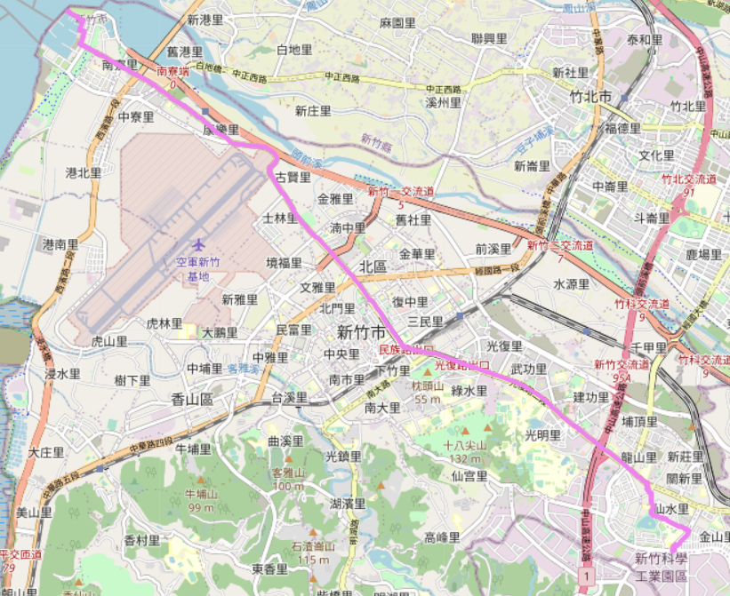

A*:

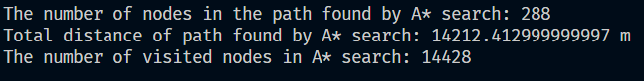 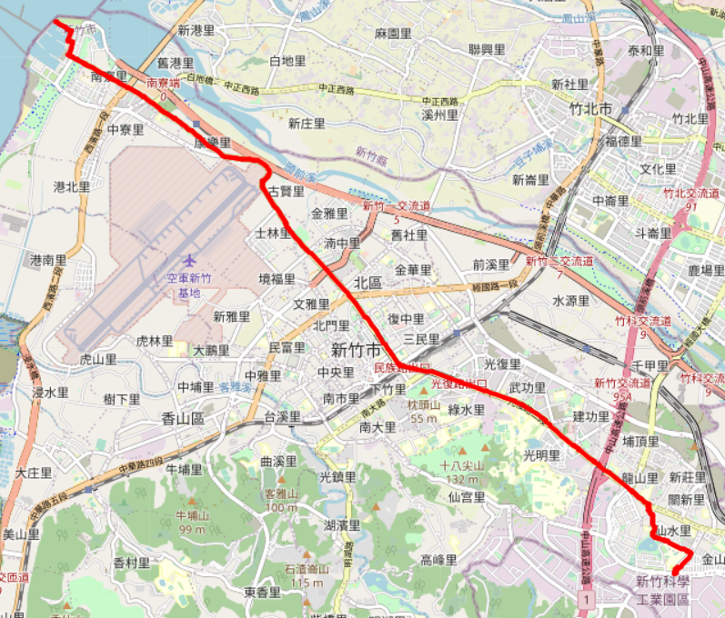

**Part III. Question Answering (12%):**

1. Please describe a problem you encountered and how you solved it.

I can not successfully install the jupyter notebook at first and my drive have some stange

problems at the same time, so I think for a long time how to solve it. After all, I chose still use vscode in my laptop and write a main.py to run it, and I use fmap.save to save the map

into html file.

1. Besides speed limit and distance, could you please come up with another attribute that is essential for route findingin the real world? Please explain the rationale.

The preference for every different road.

Some drivers prefer to drive on a road which is straight and wide instead of the twisty road or narrow road.

1. As mentioned in the introduction, a navigation system involves mapping, localization, and route finding. Please suggest possible solutions for **mapping** and **localization** components?

mapping: Collect data like the name of roads or stores. Construct a coordinate system and put the items on it. Convert the coordinate into the map we can see.

localization: Collect the data from sensors like GPS on ourselves. Combine with the place on the map.

1. The estimated time of arrival (ETA) is one of the features of Uber Eats. To provide accurate estimates for users, Uber Eats needs to dynamically update ETA based on their mechanism. Please define a **dynamic heuristic** **equation** for ETA and explain the rationale of your design. Hint: You can consider meal prep time, delivery priority, multiple orders, etc.

ETA = M + D / V + T + W + O

M: meal preparing time

D: remaining distance

V: average velocity of the vehicle

T: traffic or congestion factor

W: weather effect

O: others